‘Little Big Things’

World Mental Health Day campaign

Campaign toolkit (MASTER)

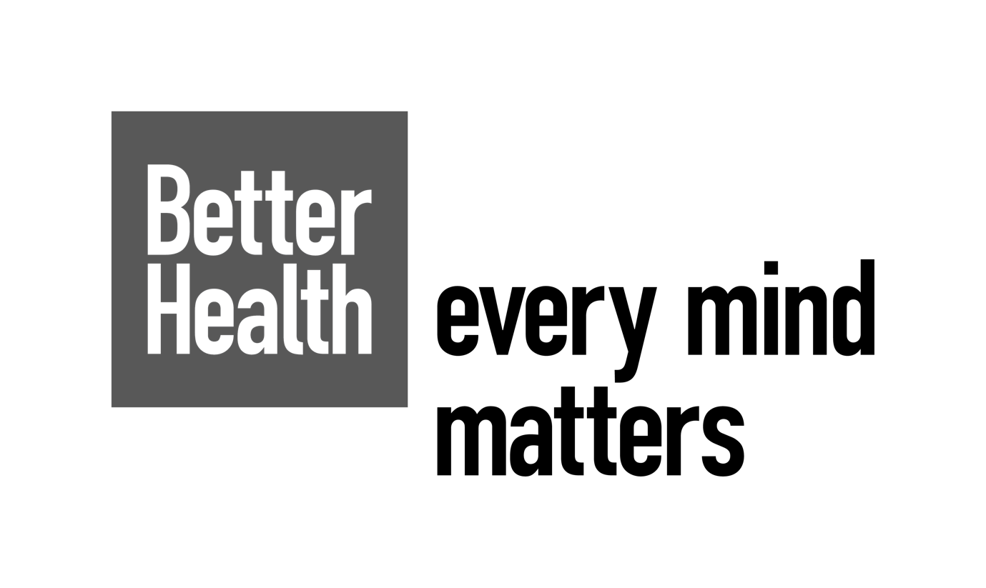

TOOLKIT OVERVIEW
This toolkit contains information to help you to promote the campaign. It includes:
- Better Health-Every Mind Matters overview
- Better Health-Every Mind Matters campaign overview
- Key messages
- Suggested copy and assets for social media

There are a range of free Better Health - Every Mind Matters resources, both printed for order and downloadable, on the Campaign Resource Centre available to all partners who want to use and support the campaign.

The resources, both digital for download and orderable printed, include:
- Social media assets
- Posters
- Accessible materials
Campaign Resource Centre
Better Health Every Mind Matters | Campaigns | Campaign Resource Centre (dhsc.gov.uk)

BETTER HEALTH-EVERY MIND MATTERS OVERVIEW

Every Mind Matters is a campaign and digital resource designed to empower people to look after their mental wellbeing and support that of others. It focuses on promoting mental wellbeing as well as addressing the four most commonly reported, subclinical mental health concerns: anxiety, low mood, stress, and trouble sleeping.

The programme offers a range of evidence-based self-care actions and free resources designed to help people take care of their own mental health and prevent common concerns from escalating into mental health disorders.

Available on the website is a free, NHS-approved Mind Plan. By answering five short questions people get a personalised mental health action plan, providing practical tips to help them deal with stress and anxiety, boost their mood, sleep better, and feel more in control. People can also join a 4-week email programme where they can get reminders, swap in new tips and are encouraged to make looking after their mental wellbeing part of their everyday routine. In addition, we have an email programmes focused specifically on ‘easing your anxiety’ and ‘putting your sleep first’.

Useful links:

Website
https://www.nhs.uk/every-mind-matters/

Mind Plan
https://www.nhs.uk/every-mind-matters/mental-wellbeing-tips/your-mind-plan-quiz/

Self-help CBT techniques
https://www.nhs.uk/every-mind-matters/mental-wellbeing-tips/self-help-cbt-techniques/

Anxiety easing email programme
https://anxiety.ecrm-registration.nhs.uk/

Putting sleep first programme
https://sleep.ecrm-registration.nhs.uk/

Mindfulness and Meditation
https://www.nhs.uk/every-mind-matters/mental-wellbeing-tips/what-is-mindfulness/
https://www.nhs.uk/every-mind-matters/mental-wellbeing-tips/how-to-meditate-for-beginners/

Remember to use the campaign hashtag #everymindmatters when you can.
All the campaign specific resources can be found on the Campaign Resource Centre: https://campaignresources.dhsc.gov.uk/campaigns/better-health-every-mind-matters/every-mind-matters-find-your-little-big-thing-resources/

BETTER HEALTH - EVERY MIND MATTERS WORLD MENTAL HEALTH DAY CAMPAIGN OVERVIEW
Around World Mental Health Day (Tuesday 10th October) Every Mind Matters will launch a campaign to encourage people to ‘find your little big thing’ and highlight that ‘doing the little things can make a big difference to your mental health.’ Aimed at 25–54-year-olds but weighted towards those that are struggling and most at risk of mental health problems, the campaign will launch across video-on-demand, digital audio, online video, social and digital.
KEY MESSAGING
The below key messages are to be communicated to raise awareness of the guidance and tools available to help adults take care of their mental wellbeing and seek support if needed.

Primary messages

- Every Mind Matters is launching a new campaign that encourages and helps us to ‘find your little big thing’ hero-ing the little things we can do, which can make a big difference to our mental health
- Making time for your mental wellbeing is important - and embedding these little things as part of your routine can help you feel better and more in control
- These little things can include:
  - Getting physically active – like taking a walk
  - Managing your thoughts and feelings with the help of CBT
  - Talking to someone you trust
  - Getting the most from your sleep – like avoiding screen-time an hour before bed or getting out of bed and doing something simple until you feel tired again
  - Getting closer to nature
  - Planning something nice to look forward to
- Little things like (a daily walk / a regular chat) can make a big difference to your mental health
- Every Mind Matters website has lots of NHS-approved tips and advice to help you ‘find your little big thing’
- Get a free, personalised Mind Plan - a mental health action plan that provides practical tips to help you deal with anxiety and stress, boost your mood, sleep better, and feel more in control.

Remember to use the campaign hashtag #everymindmatters when you can.

Call to action

- Find your little big thing at Every Mind Matters

Secondary messages (our little actions)

Get active
- Getting active is a natural mood booster – try making it part of your routine

Manage your feelings
- Learn to catch, check, and change unhelpful thoughts with Cognitive Behavioural Therapy

Talk to someone
- Talking to someone we trust about our feelings can improve our mental wellbeing

Better sleep
- Awake at night? Get out of bed and do something simple until you feel tired again

Get in nature
- Regularly spending time in nature can boost your mood and help you relax

Plan ahead
- Planning something to look forward to can counter boredom and energise you

Short form copy example

Headline: Find your little big thing

There are little things we can all do to look after our mental wellbeing, and these can make a big difference to how we feel.

Search Every Mind Matters for free, NHS approved advice and simple tips to help you look after your mental wellbeing and see whether you can make them part of your daily routine.

Find your little big thing.

SUGGESTED SOCIAL COPY AND ASSETS
Please support Every Mind Matters through your own social media channels by creating your own posts or liking and sharing the social content posted from:
Department of Health and Social Care
- Facebook account: @DHSCgovuk
- Twitter account: @DHSCgovuk
NHS
- Facebook account: @NHSWebsite
- Instagram account: @nhs
- Twitter account: @NHSuk
- Snapchat account: nhs_uk
- TikTok account: @nhsuk
Please find below some example social posts that can be posted on your social channels.
Remember to use the campaign hashtag #everymindmatters when you can.
Campaign execution
We have created a series of social media assets to encourage people to ‘find your little big thing.’ These assets can either drive people to our website or our Mind Plan – where, by answering 5 simple questions, people get a free, personalised mental health action plan with tips on how to deal with stress and anxiety, boost their mood, sleep better and feel more in control.

Example post copy:
- For better mental health find your little big thing at Every Mind Matters (link out to website or Mind Plan)
- For better mental health find your little big thing at Every Mind Matters (link out to website or Mind Plan)
- To help ease anxiety find your little big thing at Every Mind Matters (link out to website or Mind Plan)
- To help ease stress find your little big thing at Every Mind Matters (link out to website or Mind Plan)
- To help low mood find your little big thing at Every Mind Matters (link out to website or Mind Plan)
- For better sleep find your little big thing at Every Mind Matters (link out to website or Mind Plan)

Assets in 1:1 and 9:16
https://campaignresources.dhsc.gov.uk/campaigns/better-health-every-mind-matters/every-mind-matters-find-your-little-big-thing-resources/

‘Little things’ featured include:
- Walking
- Chatting
- Breathing exercises

Influencers

We’ve also worked with a range of influencers to help bring to life ‘doing the small things can make a big difference to how you feel’

If able, please re-share their organic content during w/c 9th October (around World Mental Health Day). Details below

- Erin - https://www.instagram.com/mumlifewitherin/
- Koji - https://www.instagram.com/kojisrevenge/

